Geometric DeepLearning for subject-independent epileptic seizure prediction using scalp EEG signals

**TABLE OF CONTENTS**

|  |  |  |
| --- | --- | --- |
| **CHAPTER** | **TITLE** | **PAGE NO** |
|  | **ABSTRACT** |  |
|  | **INTRODUCTION** |  |
|  | * 1. General Introduction |  |
|  | * 1. Project Objectives |  |
|  | * 1. Problem Statement |  |
|  | **SYSTEM** **PROPOSAL** |  |
|  | * 1. Existing System |  |
|  | * + 1. Advantages |  |
|  | * 1. Proposed System |  |
|  | 2.2.1 Disadvantages |  |
|  | * 1. Literature Survey |  |
|  | **SYSTEM DIAGRAMS** |  |
|  | * 1. Architecture Diagram |  |
|  | * 1. Flow Diagram |  |
|  | * 1. UML Diagrams |  |
|  | **IMPLEMENTATION** |  |
|  | * 1. Modules |  |
|  | * 1. Modules Description |  |
|  | **SYSTEM** **REQUIREMENTS** |  |
|  | * 1. Hardware Requirements |  |
|  | * 1. Software Requirements |  |
|  | * 1. Software Description |  |
|  | * 1. Testing of Products |  |
|  | **CONCLUSION** **AND** **FUTURE** **ENHANCEMENT** |  |
|  | * 1. Conclusion |  |
|  | * 1. Future Enhancement |  |
|  | **SAMPLE** **CODING** **AND** **SAMPLE** **SCREENSHOT** |  |
|  | **REFERENCES** |  |

**ABSTRACT**

Electroencephalogram (EEG) signal-based emotion recognition has attracted wide interests in recent years and has been broadly adopted in medical, affective computing, and other relevant fields. Depression has become a leading mental disorder worldwide. Evidence has shown that subjects with depression exhibit different spatial responses in neurophysiological signals from the healthy controls when they are exposed to positive and negative. We focus our analysis in the main aspects involved in the recognition process (e.g., subjects, features extracted, classifiers), and compare the works per them. We propose the emotional activation curve to demonstrate the activation process of emotions. The algorithm first extracts features from EEG signals and classifies emotions using machine learning techniques, in which different parts of a trial are used to train the proposed model and assess its impact on emotion recognition results. The primary objective of this project was to improve the performance of emotion recognition using brain signals by applying a novel and adaptive channel selection method that acknowledges that brain activity has a unique behavior that differs from one person to another and one emotional state to another. The result shows that our proposed method significantly improves the accuracy of classifying depression patients emotion as positive and negative.

1. **INTRODUCTION**
   1. **GENERAL INTRODUCTION**

DEPRESSION, as a common illness worldwide, is classified as a mood disorder and described as feelings of sadness or anger that interfere with a person’s everyday activities. According to the World Health Organization, it is likely to be the leading global disease by 2030. Depression disorder is a pathological process that causes many symptoms, resulting in limited mental and physical functionality. It is often accompanied by cognitive impairments, which may increase the risk of Alzheimer’s disease and suicide and accelerate cognitive decline. The earlier depression is detected, the easier it is to treat. As a low-cost, noninvasive acquisition, and high temporal resolution technique, electroencephalography is widely used in neural systems and rehabilitation engineering. Acharya et al. proposed a typical computer-aided system for electroencephalogram (EEG)-based diagnosis of depression, which primarily includes an offline and online system. This paper is focused on the experimental paradigm, emotion feature extraction, feature selection, machine learning, and the dataset for training and testing, particularly on spatial information feature extraction and selection. This focus was chosen because many studies have shown that subjects with depression exhibit different spatial responses in neurophysiological signals compared to healthy controls, when they are exposed to stimuli.

Many studies have been conducted on depression; some studies focused on the resting-state, whereas others focused on tasks. For example, Li et al. performed a study on the EEG-based brain electrical source of mildly depressed subjects, which suggested that depressed subjects spent more time viewing negative emotional faces, causing a dysregulation in temporal pole activity. Liao et al. collected 54 resting-state EEG signals, 6 s in length, from 12 patients with depression and 12 healthy controls, and Yang et al. extracted 24 resting-state EEG signals, 8 s in length, from 17 depressed patients and 17 control subjects; both studies resulted in a classification accuracy above 80% . Wu et al. recorded the EEG for a resting-state session, followed by an emotion-induction session, from 55 participants (24 with major depressive disorder (MDD) and 31 healthy controls), considering that the ability to distinguish MDD using resting-state EEG reaches a bottleneck, which provides a higher accuracy than emotion-induction EEG of above 83%. Li et al. conducted an experiment on the facial expression viewing task (emotional and neutral blocks) involving 48 college students, 24 of whom were considered depressed and 24 healthy, which provided an accuracy of 85.62% for the detection of depressed and healthy students using a convolutional neural network. The participants of our experiment were from the Shanghai Mental Health Center and included 16 patients with depression (Dep) and 14 healthy controls (HC); the participants were presented with the face in-the-crowd task stimuli of six human faces.

EEG signals are nonstationary and nonlinear signals, similar to many other physiological signals. To analyze these signals, linear and nonlinear features are typically used, such as the power spectrum density, Lempel-Ziv complexity, variance, mobility, fluctuations, Higuchi fractal, approximate entropy, Kolmogorov entropy, correlation dimension, Lyapunov exponent, and permutation entropy. To analyze our hypothesis effectively, it was necessary to select optimal features, as some dimension features may mislead the classifiers. The BestFirst, GreedyStepwise (GSW), GeneticSearch, and RankSearch approaches, based on correlation feature selection, are typical data mining search methods, and the BayesNet, support vector machine (SVM), k-nearest neighbor (KNN), logistic regression (LR), linear discriminant analysis (LDA), and random forest approaches are widely used for discriminating classes. Hosseinifard et al. extracted four nonlinear features from EEG signals and obtained the highest classification accuracy of depressed patients and controls by using the correlation dimension and LR approaches, among the KNN, LDA, and other nonlinear feature selection methods, with a genetic algorithm employed to select features. Li et al. calculated eight linear features and nine nonlinear features from theta (4–8 Hz), alpha (8–13 Hz), and beta (13–30 Hz) waves, which yielded high accuracy using GSW and KNN for the beta frequency band. As the electrode channels are located in different areas on the surface of the human’s head, the channel dimension contains spatial information of EEG. When EEG channels are chosen, the optimal spatial information should be selected. The common spatial pattern (CSP) has been proven to be one of the most effective algorithms for a brain-computer interface (BCI) for the optimization of the spatial-spectral filter, and many novel approaches have been proposed accordingly. This paper presents an effective EEG-based detection method for depression classification by employing spatial information, namely the task-related common spatial pattern (TCSP).

Subject-independent k-fold cross-validation (CV) and leave-one-subject-out (LOSO) CV are two widely used EEG classification strategies. In fact, when k = 1, the LOSO method is a special case of the k-fold technique. As the LOSO approach can enjoy more training data and adjust super-parameters on each subject, it will always achieve better results compared with the k-fold method. When detecting a potential depression patient, we chose the LOSO strategy to evaluate the model for detecting depression patients in this study, to make the best use of the existing data.

* 1. **PROJECT OBJECTIVES**
* The main objective of this project was to improve the performance of emotion recognition using brain signals.
* To effectively classify and predict the emotions.
* To enhance the performance of overall prediction result.
  1. **PROBLEM STATEMENT**

There has been much research done from EEG with different result. This different result has been due to diversity in different aspects of methods used in the research. The diversities are mainly in aspects of emotion selection, experiment environment, techniques of data preprocessing and feature selection. Due to all this factors, it is not easy to compare and chose the method which can be said as the best classifier. Hence, there is always room for the development of better classifier suitable for specific application.

1. **SYSTEM PROPOSAL**

**2.1 EXISTING SYSTEM**

In existing system, machine learning approaches to obtain the properties of physiological signals in the time, frequency, and nonlinear fields. This method accomplishes greater precision in the classification of emotional states. To recognize emotion from raw EEG signals to detect features next to the layer, and features were classified into low/high arousal, valence, and liking sequentially. The feature extraction phase used a statistical approach based on specific features for different frequency ranges. Features chosen by this statistical approach exceeded univariate and multivariate features. There are common and unique issues about the conducted approaches for emotion detection based on different classifiers. The existing approach is high if real-time processing is implemented. Accordingly, there is a need to enhance the accuracy of emotion detection and classification and reduce the complexity of the utilized approaches.

**2.1.1 DISADVANTAGES**

* Less effective.
* Loss of Information.
* Incorrect Prediciton Results.
* Some specific problem in extract features.

**2.2 PROPOSED SYSTEM**

The proposed model shows the main steps for preprocessing stage, feature extraction, and classification. To develop an effective EEG-based detection method for depression classification by employing spatial information. In this process take EEG signal dataset to predict depression patients emotion as positive and negative. For that the first process is to pre-process the dataset to remove missing values and null values from the taken EEG dataset. In order to classify different emotions, we need to record EEG signals from different subjects and then process them to extract different features. The data sets are made from the features and then we classify the dataset. In this process we propose machine learning (KNN) and deep learning (LSTM) algorithms to classify the depression patient’s emotion as positive and negative. Finally it improves the accuracy of classifying depression patients emotion as positive and negative.

**2.2.1 ADVANTAGES**

* Highly effective.
* Provide accurate prediction results.
* It avoids data inconsistency.
  1. **LITERATURE SURVEY**

# Title: Methods for classifying depression in single channel EEG using linear and nonlinear signal analysis

# Year: 2018

**Author: M. Bachmann et al.,**

**Methodology**

Depressive disorder is one of the leading causes of burden of disease today and it is presumed to take the first place in the world in 2030. Early detection of depression requires a patient-friendly inexpensive method based on easily measurable objective indicators. This study aims to compare various single-channel electroencephalographic (EEG) measures in application for detection of depression.The EEG recordings were performed on a group of 13 medication-free depressive outpatients and 13 gender and age matched controls. The recorded 30-channel EEG signal was analysed using linear methods spectral asymmetry index, alpha power variability and relative gamma power and nonlinear methods Higuchi's fractal dimension, detrended fluctuation analysis and Lempel-Ziv complexity. Classification accuracy between depressive and control subjects was calculated using logistic regression analysis with leave-one-out cross-validation. Calculations were performed separately for each EEG channel.All calculated measures indicated increase with depression. Maximal testing accuracy using a single measure was 81% for linear and 77% for nonlinear measures. Combination of two linear measures provides the accuracy of 88% and two nonlinear measures of 85%. Maximal classification accuracy of 92% was indicated using mixed combination of three linear and three nonlinear measures. The results of this preliminary study confirm that single-channel EEG analysis, employing the combination of measures, can provide discrimination of depression at the level of multichannel EEG analysis. The performed study shows that there is no single superior measure for detection of depression.

**Advantage**

Minimum volume ellipsoid model is proposed for performance degradation.

**Disadvantage**

Run to failure prediction is low

# Title: Brain wave frequency measurement in gamma wave range for accurate and early detection of depression

# Year: 2018

**Author**: **J. Malik, M. Dahiya, and N. Kumari**

**Methodology**

The Global System of Mobile Communication (GSM) which debuted in Nigeria in August 2001 was greeted with much celebration as the country finally joined the League of the GSM nations, though after less economically buoyant African countries such as Botswana, Mozambique, Uganda and Tanzania. Fourteen years after the introduction, Issues and challenges has been raised on why subscribers are been ripped of their money and short changed with epileptic services. This arises from the myriad of problems ranging from congestion to the poor network delivery. This paper discusses the evolution of GSM services in Nigeria, the range of services available and the issues involved in its operation in the last fourteen years. Not forgetting the benefit it has brought to the Nigerian economy. Suggestions are also made on how Nigeria can reap more benefits of the GSM communication. According to the World Health Organization factsheet published in April 2016, there is one suicide committed every 40 seconds which averages for 2,160 suicides per day and over 8,00,000 suicides every year. Moreover, suicide is the third leading cause of death in the world for those aged 15-44 years. Research has consistently shown a strong link between suicide and a mental illness called depression, with 90% of the people who die by suicide having an existing mental illness. It is depression that causes people to commit suicide 95% of the times. We tend to lose about 3% of our population each year to depression. This establishes a thorough background of how severe this disease is and how it is taking our own species away from us. We are losing our workforce and human resources to a mental illness. Often called the “cold” of the brain, depression – like any other disease – has its own symptoms, causes, diagnosis, treatments, and complications. We are well aware of the treatments, yet we lose 2,160 humans to suicide every day. One of the major causes of this is late diagnosis. Depression turns severe over time – minor depression turns into psychotic depression. People often overlook the symptoms of minor depression, considering their feelings to be a mere sign of slight sadness. Sometimes this feeling of “slight sadness” persists over a long duration of time and turns into a major depression. The earlier depression is diagnosed, the easier it is for effective treatment. This work focuses on the same – the timely and accurate diagnosis of depression.

**Advantage**

It performs accurate classification of health state in comparison with other methods**.**

**Disadvantage**

It is low in efficiency.

# Title: Seizure prediction in scalp EEG using 3D convolutional neural networks with an image-based approach

# Year: 2019

**Author: A. R. Ozcan and S. Erturk**

**Methodology**

Epileptic seizures occur as a result of a process that develops over time and space in epileptic networks. In this study, we aim at developing a generalizable method for patient-specific seizure prediction by evaluating the spatio-temporal correlation in the features obtained from multichannel EEG signals. Spectral band power, statistical moment and Hjorth parameters are used to reveal the frequency and time domain features of the EEG signals. The features are given as input to a convolutional neural network (CNN) by transforming into a sequence of multi-color images according to the topology of the EEG channels. The multi-frame 3D CNN model is proposed to evaluate the temporal and spatial correlation in training data collectively. The proposed 3D CNN model achieves a sensitivity of 85.7%, a false prediction rate of 0.096/h, and a proportion of time-in-warning of 10.5%, in the tests performed with 16 patients from the CHB-MIT scalp EEG dataset. The results show that the superiority of the proposed method to a Poisson based random predictor was statistically significant for 93.7% of the patients, at significance level of 0.05. Our experiments with various timing constraints show that epileptic stage lengths are an important factor affecting seizure performance. We present a subject-specific seizure prediction method that is robust for unbalanced data and can be generalized to any scalp EEG dataset without the need for subject-specific engineering.

**Advantage**

More Reliable.

**Disadvantage**

It is less in efficiency and not give perfect result.

# Title: Depression detection using relative EEG power induced by emotionally positive images and a conformal kernel support vector machine

# Year: 2018

**Author**: **C.-T. Wu, D. G. Dillon, H.-C. Hsu, S. Huang, E. Barrick, and Y.-H. Liu**

**Methodology**

Electroencephalography (EEG) can assist with the detection of major depressive disorder (MDD). However, the ability to distinguish adults with MDD from healthy individuals using resting-state EEG features has reached a bottleneck. To address this limitation, we collected EEG data as participants engaged with positive pictures from the International Affective Picture System. Because MDD is associated with blunted positive emotions, we reasoned that this approach would yield highly dissimilar EEG features in healthy versus depressed adults. We extracted three types of relative EEG power features from different frequency bands (delta, theta, alpha, beta, and gamma) during the emotion task and resting state. We also applied a novel classifier, called a conformal kernel support vector machine (CK-SVM), to try to improve the generalization performance of conventional SVMs. We then compared CK-SVM performance with three machine learning classifiers: linear discriminant analysis (LDA), conventional SVM, and quadratic discriminant analysis. The results from the initial analyses using the LDA classifier on 55 participants (24 MDD, 31 healthy controls) showed that the participant-independent classification accuracy obtained by leave-one-participant-out cross-validation (LOPO-CV) was higher for the EEG recorded during the positive emotion induction versus the resting state for all types of relative EEG power. Furthermore, the CK-SVM classifier achieved higher LOPO-CV accuracy than the other classifiers. The best accuracy (83.64%; sensitivity = 87.50%, specificity = 80.65%) was achieved by the CK-SVM, using seven relative power features extracted from seven electrodes. Overall, combining positive emotion induction with the CK-SVM classifier proved useful for detecting MDD on the basis of EEG signals. In the future, this approach might be used to develop a brain–computer interface system to assist with the detection of MDD in the clinic. Importantly, such a system could be implemented with a low-density electrode montage (seven electrodes), highlighting its practical utility.

**Advantage**

High Efficiency.

**Disadvantage**

Low in accuracy performance.

# Title: Remaining useful life prognosis of supercapacitors under temperature and voltage aging conditions

# Year: 2019

**Author: X. Li et al.**

**Methodology**

Electroencephalography (EEG)–based studies focus on depression recognition using data mining methods, while those on mild depression are yet in infancy, especially in effective monitoring and quantitative measure aspects. Aiming at mild depression recognition, this study proposed a computer-aided detection (CAD) system using convolutional neural network (ConvNet). However, the architecture of ConvNet derived by trial and error and the CAD system used in clinical practice should be built on the basis of the local database; we therefore applied transfer learning when constructing ConvNet architecture. We also focused on the role of different aspects of EEG, i.e., spectral, spatial, and temporal information, in the recognition of mild depression and found that the spectral information of EEG played a major role and the temporal information of EEG provided a statistically significant improvement to accuracy. The proposed system provided the accuracy of 85.62% for recognition of mild depression and normal controls with 24-fold cross-validation (the training and test sets are divided based on the subjects). Thus, the system can be clinically used for the objective, accurate, and rapid diagnosis of mild depression.

Depression is a common mental illness. According to the World Health Organization (WHO), it is expected that by 2020, depression will replace cancer and become the second largest disease in the world. In addition, new data showed that the prevalence of depression might increase gradually, especially among college students. The impact of factors such as coursework and examinations will increase the number of college students with depression. According to statistics, the incidence of depression in college students in Egypt, Kenya, and Ghana was 10–85%, 35.7%, and 31.1%, respectively. Mild depression is more common than depression in daily life and increases in severity over time. However, mild depression is under less focus than major depressive disorder, and the lack of effective and practical methods for mild depression detection may lead to the miss of early detection and treatment, which could help mild depression to take precautions and avoid evolution into major depression. This will positively affect both economic society and family. The most widely used methods of depressive diagnosis are currently based on the Beck depression inventory or the patient’s self-reporting information and the doctor’s clinical experience. However, the accuracy of diagnosis may be influenced by a variety of factors, including the degree of doctor’s proficiency and patient’s cooperation, with a strong subjective influence. Therefore, finding an objective and effective method for identifying mild depression is an urgent requisite.

**Advantage**

Good in Performance.

**Disadvantage**

Not Reliable

# Title: Atypical temporal dynamics of resting state shapes stimulus-evoked activity in depression—An EEG study on rest–stimulus interaction

# Year: 2019

**Author: A. Wolff et al.,**

**Methodology**

Major depressive disorder (MDD) is a complex psychiatric disorder characterized by changes in both resting state and stimulus-evoked activity. Whether resting state changes are carried over to stimulus-evoked activity, however, is unclear. We conducted a combined rest (3 min) and task (three-stimulus auditory oddball paradigm) EEG study in n=28 acute depressed MDD patients, comparing them with n=25 healthy participants. Our focus was on the temporal dynamics of both resting state and stimulus-evoked activity for which reason we measured peak frequency (PF), coefficient of variation (CV), Lempel-Ziv complexity (LZC), and trial-to-trial variability (TTV). Our main findings are: i) atypical temporal dynamics in resting state, specifically in the alpha and theta bands as measured by peak frequency (PF), coefficient of variation (CV) and power; ii) decreased reactivity to external deviant stimuli as measured by decreased changes in stimulus-evoked variance and complexity—TTV, LZC, and power and frequency sliding (FS and PS); iii) correlation of stimulus related measures (TTV, LZC, PS, and FS) with resting state measures. Together, our findings show that resting state dynamics alone are atypical in MDD and, even more important, strongly shapes the dynamics of subsequent stimulus-evoked activity. We thus conclude that MDD can be characterized by an atypical temporal dynamic of its rest–stimulus interaction; that, in turn, makes it difficult for depressed patients to react to relevant stimuli such as the deviant tone in our paradigm.

Major depressive disorder (MDD) is a complex psychiatric disorder that includes affective, cognitive, vegetative, sensorimotor, social, and perceptual changes. Neuronally, changes in stimulus-evoked activity in response to especially affective and cognitive stimuli have been reported in MDD, including event-related potential (ERP) changes during auditory target detection paradigms as well as atypical power in theta (5–8 Hz) and/or alpha (7–13 Hz) frequency ranges . The origin of these neuronal changes in stimulus-evoked activity in MDD, however, remains unclear.

Recent studies have demonstrated changes in the resting state in MDD. FMRI resting state studies show atypical functional connectivity, especially in anterior regions of the prefrontal cortex, as well as in other networks such as the default-mode network, while EEG resting state studies demonstrate atypical activity, especially in theta and alpha frequencies in MDD. Given the overlap of both rest and task findings in theta and alpha frequencies, one would suggest that resting state changes may also shape stimulus-evoked activity in depression. This link is yet to be shown.

**Advantage**

Efficiency is good.

**Disadvantage**

Not give accurate prediction result.

# Title: EEG-based mild depressive detection using feature selection methods and classifiers

# Year: 2016

**Author**: **X. Li, B. Hu, S. Sun, and H. Cai**

**Methodology**

Depression has become a major health burden worldwide, and effectively detection of such disorder is a great challenge which requires latest technological tool, such as Electroencephalography (EEG). This EEG-based research seeks to find prominent frequency band and brain regions that are most related to mild depression, as well as an optimal combination of classification algorithms and feature selection methods which can be used in future mild depression detection.

An experiment based on facial expression viewing task (Emo_block and Neu_block) was conducted, and EEG data of 37 university students were collected using a 128 channel HydroCel Geodesic Sensor Net (HCGSN). For discriminating mild depressive patients and normal controls, BayesNet (BN), Support Vector Machine (SVM), Logistic Regression (LR), k-nearest neighbor (KNN) and RandomForest (RF) classifiers were used. And BestFirst (BF), GreedyStepwise (GSW), GeneticSearch (GS), LinearForwordSelection (LFS) and RankSearch (RS) based on Correlation Features Selection (CFS) were applied for linear and non-linear EEG features selection. Independent Samples T-test with Bonferroni correction was used to find the significantly discriminant electrodes and features.

Data mining results indicate that optimal performance is achieved using a combination of feature selection method GSW based on CFS and classifier KNN for beta frequency band. Accuracies achieved 92.00% and 98.00%, and AUC achieved 0.957 and 0.997, for Emo_block and Neu_block beta band data respectively. T-test results validate the effectiveness of selected features by search method GSW. Simplified EEG system with only FP1, FP2, F3, O2, T3 electrodes was also explored with linear features, which yielded accuracies of 91.70% and 96.00%, AUC of 0.952 and 0.972, for Emo_block and Neu_block respectively.

Classification results obtained by GSW + KNN are encouraging and better than previously published results. In the spatial distribution of features, we find that left parietotemporal lobe in beta EEG frequency band has greater effect on mild depression detection. And fewer EEG channels (FP1, FP2, F3, O2 and T3) combined with linear features may be good candidates for usage in portable systems for mild depression detection.

**Advantage**

More effective and efficient**.**

**Disadvantage**

Not give accurate prediction result.

1. **SYSTEM DIAGRAMS**

**3.1 ARCHITECTURE DIAGRAM**

**Dataset**

**Data preprocess**

**Feature Selection**

**Splitting Dataset into Train**

**and Test**

**Regression**

**Result Generation**

**Prediction**



**Select and View Dataset**

**3.2 FLOW DIAGRAM**

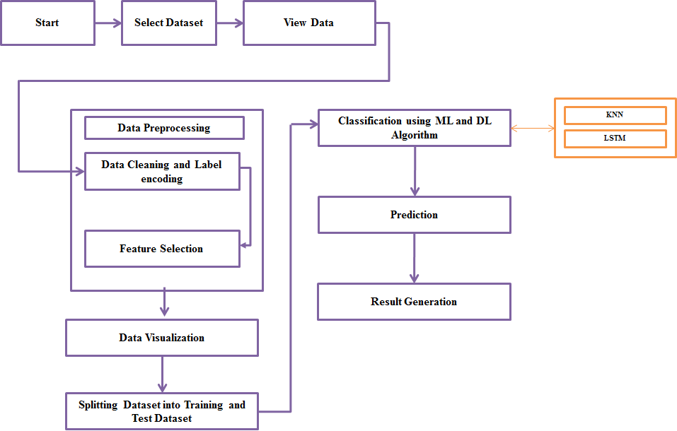

**3.3 UML DIAGRAMS**

**USE CASE DIAGRAM**

**ANALYST**

**CLASS DIAGRAM**

**DATASET**

Select dataset ()

Import dataset ()

View dataset ()

**FEATURE SELECTION**

Dataset Splitting Train and Test

Feature Select ()

**DATA PREPROCESSING**

Data Normalization ()

Label Encoding ()

**REGRESSION**

Detection ()

Prediction ()

**RESULT GENERATION**

Result Generation ()

**SEQUENCE DIAGRAM**

DATA SELECTION & VIEW

PREPROCESSING

FEATURE

SELECTION

REGRESSION

Select path

Preview Data

Data Preprocess

Feature Selection

Regression

RESULT GENERATION

Import Dataset

Splitting Dataset into Training and Test Data

Label encoding

**ER DIAGRAM**

**DATA SELECTION & LOAD**

**DATA PREPROCESS**

**FEATURE SELECTION**

**REGRESSION**

**RESULT GENERATION**

**FEATURES**

1. **IMPLEMENTATION**

**4.1 MODULES**

* Data selection and loading
* Data Preprocessing
* Feature Selection
* Classification
* Prediction
* Result Generation

**4.2 MODULE DESCRIPTION**

**DATA SELECTION AND LOADING**

The data selection is the process of selecting the data for predicting the depression patient emotion from the EEG emotion dataset. This is a dataset of EEG brainwave data that has been processed with our original strategy of statistical extraction. The data was collected from two people (1 male, 1 female) for 3 minutes per state - positive, neutral, negative. We used a Muse EEG headband which recorded the TP9, AF7, AF8 and TP10 EEG placements via dry electrodes. Six minutes of resting neutral data is also recorded, the stimuli used to evoke the emotions.

**DATA PREPROCESSING**

Data pre-processing is the process of removing the unwanted data from the dataset.

* Missing data removal
* Encoding Categorical data

Missing data removal: In this process, the null values such as missing values are removed using imputer library.

Encoding Categorical data: That categorical data is defined as variables with a finite set of label values. That most machine learning algorithms require numerical input and output variables. That an integer and one hot encoding is used to convert categorical data to integer data.

Pre-processing refers to the transformations applied to our data before feeding it to the algorithm. Data Preprocessing is a technique that is used to convert the raw data into a clean data set. In other words, whenever the data is gathered from different sources it is collected in raw format which is not feasible for the analysis.

For achieving better results from the applied model in Machine Learning projects the format of the data has to be in a proper manner. Some specified Machine Learning model needs information in a specified format. Another aspect is that data set should be formatted in such a way that more than one Machine Learning and Deep Learning algorithms are executed in one data set and best out of them is chosen.

**FEATURE SCALING**

Feature Scaling is **a technique to standardize the independent features present in the data in a fixed range**. If feature scaling is not done, then a machine learning algorithm tends to weigh greater values, higher and consider smaller values as the lower values, regardless of the unit of the values.

**SPLITTING DATASET INTO TRAIN AND TEST DATA**

Data splitting is the act of partitioning available data into two portions, usually for cross-validator purposes. One portion of the data is used to develop a predictive model. And the other to evaluate the model's performance. Separating data into training and testing sets is an important part of evaluating data mining models. Typically, when you separate a data set into a training set and testing set, most of the data is used for training, and a smaller portion of the data is used for testing.

The train-test split procedure is used to estimate the performance of machine learning algorithms when they are used to make predictions on data not used to train the model.

It is a fast and easy procedure to perform, the results of which allow you to compare the performance of machine learning algorithms for your predictive modeling problem. Although simple to use and interpret, there are times when the procedure should not be used, such as when you have a small dataset and situations where additional configuration is required, such as when it is used for classification and the dataset is not balanced.

**CLASSIFICATION**

Classification is a process related to categorization, the process in which ideas and objects are recognized, differentiated, and understood. In this project, the KNN and LSTM classification algorithm is used for classifying the data. K-Nearest Neighbour is one of the simplest Machine Learning algorithms based on Supervised Learning technique. K-NN algorithm assumes the similarity between the new case/data and available cases and put the new case into the category that is most similar to the available categories. It classifies a new data point based on the similarity. This means when new data appears then it can be easily classified into a well suite category by using K- NN algorithm. Long short-term memory (**LSTM**) is an artificial recurrent neural network (RNN) architectureused in the field of deep learning. Unlike standard feedforward neural networks, LSTM has feedback connections. It can process not only single data points (such as images), but also entire sequences of data. The Long Short-Term Memory (LSTM) cell can process data sequentially and keep its hidden state through time.

**RESULT GENERATION**

The Final Result will get generated based on the overall classification and prediction. The performance of this proposed approach is evaluated using some measures like,

**Accuracy**

Accuracy of classifier refers to the ability of classifier. It predicts the class label correctly and the accuracy of the predictor refers to how well a given predictor can guess the value of predicted attribute for a new data.

AC= (TP+TN)/(TP+TN+FP+FN)

**Precision**

Precision is defined as the number of true positives divided by the number of true positives plus the number of false positives.

Precision=TP/ (TP+FP)

**Recall**

Recall is the number of correct results divided by the number of results that should have been returned. In binary classification, recall is called sensitivity. It can be viewed as the probability that a relevant document is retrieved by the query.

Recall=TP/(TP+FN)

**F-Measure**

F measure (F1 score or F score) is a measure of a test's accuracy and is defined as the weighted harmonic mean of the precision and recall of the test.

F-measure=2TP/(2TP+FP+FN)

1. **SYSTEM REQUIREMENTS**

**5.1 Hardware Requirements**

* System : Pentium IV 2.4 GHz
* Hard Disk : 1000 GB
* Monitor : 15 VGA color
* Mouse : Logitech.
* Keyboard : 110 keys enhanced
* Ram : 4GB

**5.2 Software Requirements**

* O/S : Windows 7
* Language : python.
* IDE : Anaconda - Spyder

**5.3 SOFTWARE DESCRIPTION**

**Python**

Python is a general-purpose interpreted, interactive, object-oriented, and high-level programming language. It was created by Guido van Rossum during 1985- 1990. Like Perl, Python source code is also available under the GNU General Public License (GPL). This tutorial gives enough understanding on Python programming language.

Python is a popular programming language. It was created in 1991 by Guido van Rossum.

It is used for:

* web development (server-side),
* software development,
* mathematics,
* System scripting.

Python can be used on a server to create web applications. Python can be used alongside software to create workflows. Python can connect to database systems. It can also read and modify files. Python can be used to handle big data and perform complex mathematics. Python can be used for rapid prototyping, or for production-ready software development.

Python works on different platforms (Windows, Mac, Linux, Raspberry Pi, etc). Python has a simple syntax similar to the English language. Python has syntax that allows developers to write programs with fewer lines than some other programming languages.

Python runs on an interpreter system, meaning that code can be executed as soon as it is written. This means that prototyping can be very quick. Python can be treated in a procedural way, an object-orientated way or a functional way.

Python is a high-level, interpreted, interactive and object-oriented scripting language. Python is designed to be highly readable. It uses English keywords frequently where as other languages use punctuation, and it has fewer syntactical constructions than other languages.

* **Python is Interpreted** − Python is processed at runtime by the interpreter. You do not need to compile your program before executing it. This is similar to PERL and PHP.
* **Python is Interactive** − you can actually sit at a Python prompt and interact with the interpreter directly to write your programs.
* **Python is Object-Oriented** − Python supports Object-Oriented style or technique of programming that encapsulates code within objects.
* **Python is a Beginner's Language** − Python is a great language for the beginner-level programmers and supports the development of a wide range of applications from simple text processing to WWW browsers to games.

## History of Python

Python was developed by Guido van Rossum in the late eighties and early nineties at the National Research Institute for Mathematics and Computer Science in the Netherlands.

Python is derived from many other languages, including ABC, Modula-3, C, C++, Algol-68, SmallTalk, and Unix shell and other scripting languages.

Python is copyrighted. Like Perl, Python source code is now available under the GNU General Public License (GPL).

Python is now maintained by a core development team at the institute, although Guido van Rossum still holds a vital role in directing its progress.

## Python Features

Python's features include −

* **Easy-to-learn** − Python has few keywords, simple structure, and a clearly defined syntax. This allows the student to pick up the language quickly.
* **Easy-to-read** − Python code is more clearly defined and visible to the eyes.
* **Easy-to-maintain** − Python's source code is fairly easy-to-maintain.
* **A broad standard library** − Python's bulk of the library is very portable and cross-platform compatible on UNIX, Windows, and Macintosh.
* **Interactive Mode** − Python has support for an interactive mode which allows interactive testing and debugging of snippets of code.
* **Portable** − Python can run on a wide variety of hardware platforms and has the same interface on all platforms.
* **Extendable** − you can add low-level modules to the Python interpreter. These modules enable programmers to add to or customize their tools to be more efficient.
* **Databases** − Python provides interfaces to all major commercial databases.
* **GUI Programming** − Python supports GUI applications that can be created and ported to many system calls, libraries and windows systems, such as Windows MFC, Macintosh, and the X Window system of Unix.
* **Scalable** − Python provides a better structure and support for large programs than shell scripting.

Apart from the above-mentioned features, Python has a big list of good features, few are listed below −

* It supports functional and structured programming methods as well as OOP.
* It can be used as a scripting language or can be compiled to byte-code for building large applications.
* It provides very high-level dynamic data types and supports dynamic type checking.
* It supports automatic garbage collection.
* It can be easily integrated with C, C++, COM, ActiveX, CORBA, and Java.

Python is available on a wide variety of platforms including Linux and Mac OS X.

### Python Syntax compared to other programming languages

* Python was designed to for readability, and has some similarities to the English language with influence from mathematics.
* Python uses new lines to complete a command, as opposed to other programming languages which often use semicolons or parentheses.
* Python relies on indentation, using whitespace, to define scope; such as the scope of loops, functions and classes. Other programming languages often use curly-brackets for this purpose.

**Anaconda**

Anaconda is the most popular python data science platform.

## Anaconda Distribution

With over 6 million users, the open source Anaconda Distribution is the fastest and easiest way to do Python and R data science and machine learning on Linux, Windows, and Mac OS X. It's the industry standard for developing, testing, and training on a single machine.

## Anaconda Enterprise

Anaconda Enterprise is an AI/ML enablement platform that empowers organizations to develop, govern, and automate AI/ML and data science from laptop through training to production. It lets organizations scale from individual data scientists to collaborative teams of thousands, and to go from a single server to thousands of nodes for model training and deployment.

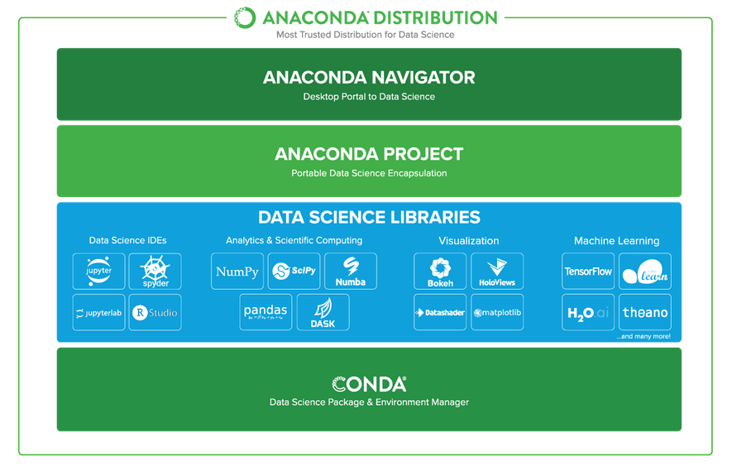

### Anaconda Data Science Libraries

* Over 1,400 Anaconda-curated and community data science packages
* Develop data science projects using your favourite IDEs, including Jupyter, JupyterLab, Spyder, and RStudio
* Analyse data with scalability and performance with Dask, numpy, pandas, and Numba
* Visualize your data with Matplotlib, Bokeh, Datashader, and Holoviews
* Create machine learning and deep learning models with Scikit-learn, Tensorflow, h20, and Theano

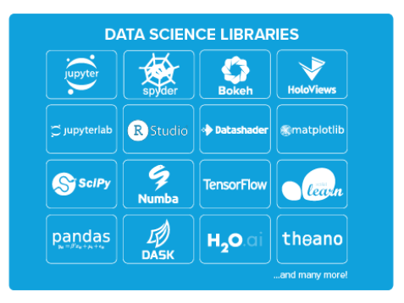

### Conda, the Data Science Package & Environment Manager

* Automatically manages all packages, including cross-language dependencies
* Works across all platforms: Linux, macOS, Windows
* Create virtual environments
* Download conda packages from Anaconda, Anaconda Enterprise, Conda Forge, and Anaconda Cloud

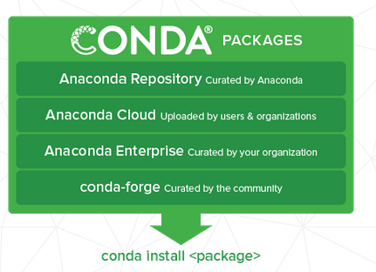

### Anaconda Navigator, the Desktop Portal to Data Science

* Install and launch applications and editors including Jupyter, RStudio, Visual Studio Code, and Spyder
* Manage your local environments and data science projects from a graphical interface
* Connect to Anaconda Cloud or Anaconda Enterprise
* Access the latest learning and community resources

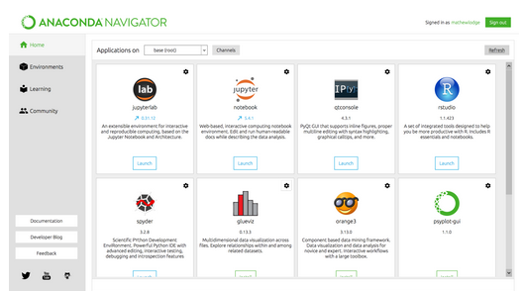

**Spyder**

Spyder is an open source cross-platform integrated development environment (IDE) for scientific programming in the Python language. ... Initially created and developed by Pierre Raybaut in 2009, since 2012 Spyder has been maintained and continuously improved by a team of scientific Python developers and the community. Strongly recommend the free, open-source Spyder Integrated Development Environment (IDE) for scientific and engineering programming, due to its integrated editor, interpreter console, and debugging tools. Spyder is included in Anaconda and other distributions.

Spyder is a powerful scientific environment written in Python, for Python, and designed by and for scientists, engineers and data analysts. It offers a unique combination of the advanced editing, analysis, debugging, and profiling functionality of a comprehensive development tool with the data exploration, interactive execution, deep inspection, and beautiful visualization capabilities of a scientific package.

Beyond its many built-in features, its abilities can be extended even further via its plugin system and API. Furthermore, Spyder can also be used as a PyQt5 extension library, allowing developers to build upon its functionality and embed its components, such as the interactive console, in their own PyQt software.

### Editor

Work efficiently in a multi-language editor with a function/class browser, code analysis tools, automatic code completion, horizontal/vertical splitting, and go-to-definition.

### IPython Console

Harness the power of as many IPython consoles as you like within the flexibility of a full GUI interface; run your code by line, cell, or file; and render plots right inline.

### Variable Explorer

Interact with and modify variables on the fly: plot a histogram or time series, edit a date frame or Numpy array, sort a collection, dig into nested objects, and more!

### Profiler

Find and eliminate bottlenecks to unchain your code's performance.

### Debugger

Trace each step of your code's execution interactively.

### Help

Instantly view any object's docs, and render your own.

**FEASIBILITY STUDY**

The feasibility study is carried out to test whether the proposed system is worth being implemented. The proposed system will be selected if it is best enough in meeting the performance requirements.

The feasibility carried out mainly in three sections namely.

**•** Economic Feasibility

• Technical Feasibility

• Behavioural Feasibility

**Economic Feasibility**

Economic analysis is the most frequently used method for evaluating effectiveness of the proposed system. More commonly known as cost benefit analysis. This procedure determines the benefits and saving that are expected from the system of the proposed system. The hardware in system department if sufficient for system development.

**Technical Feasibility**

This study centre around the system’s department hardware, software and to what extend it can support the proposed system department is having the required hardware and software there is no question of increasing the cost of implementing the proposed system. The criteria, the proposed system is technically feasible and the proposed system can be developed with the existing facility.

**Behavioural Feasibility**

People are inherently resistant to change and need sufficient amount of training, which would result in lot of expenditure for the organization. The proposed system can generate reports with day-to-day information immediately at the user’s request, instead of getting a report, which doesn’t contain much detail.

**5.4 TESTING OF PRODUCT**

**Testing of Product**

System testing is the stage of implementation, which aimed at ensuring that system works accurately and efficiently before the live operation commence. Testing is the process of executing a program with the intent of finding an error. A good test case is one that has a high probability of finding an error. A successful test is one that answers a yet undiscovered error.

Testing is vital to the success of the system.  System testing makes a logical assumption that if all parts of the system are correct, the goal will be successfully achieved.  The candidate system is subject to variety of tests-on-line response, Volume Street, recovery and security and usability test.  A series of tests are performed before the system is ready for the user acceptance testing.  Any engineered product can be tested in one of the following ways.  Knowing the specified function that a product has been designed to from, test can be conducted to demonstrate each function is fully operational.  Knowing the internal working of a product, tests can be conducted to ensure that “al gears mesh”, that is the internal operation of the product performs according to the specification and all internal components have been adequately exercised.

**UNIT TESTING**

Unit testing is the testing of each module and the integration of the overall system is done.  Unit testing becomes verification efforts on the smallest unit of software design in the module.  This is also known as ‘module testing’.  The modules of the system are tested separately.  This testing is carried out during the programming itself.  In this testing step, each model is found to be working satisfactorily as regard to the expected output from the module.  There are some validation checks for the fields.  For example, the validation check is done for verifying the data given by the user where both format and validity of the data entered is included.  It is very easy to find error and debug the system.

**INTEGRATION TESTING**

Data can be lost across an interface, one module can have an adverse effect on the other sub function, when combined, may not produce the desired major function.  Integrated testing is systematic testing that can be done with sample data.  The need for the integrated test is to find the overall system performance. There are two types of integration testing. They are:

1. Top-down integration testing.
2. Bottom-up integration testing.

**WHITE BOX TESTING**

White Box testing is a test case design method that uses the control structure of the procedural design to drive cases.  Using the white box testing methods, we derived test cases that guarantee that all independent paths within a module have been exercised at least once.

**BLACK BOX TESTING**

* Black box testing is done to find incorrect or missing function
* Interface error
* Errors in external database access
* Performance errors
* Initialization and termination errors

In ‘functional testing’, is performed to validate an application conforms to its specifications of correctly performs all its required functions. So this testing is also called ‘black box testing’.  It tests the external behaviour of the system.  Here the engineered product can be tested knowing the specified function that a product has been designed to perform, tests can be conducted to demonstrate that each function is fully operational.

**VALIDATION TESTING**

After the culmination of black box testing, software is completed assembly as a package, interfacing errors have been uncovered and corrected and final series of software validation tests begin validation testing can be defined as many, but a single definition is that validation succeeds when the software functions in a manner that can be reasonably expected by the customer.

# USER ACCEPTANCE TESTING

User acceptance of the system is the key factor for the success of the system.  The system under consideration is tested for user acceptance by constantly keeping in touch with prospective system at the time of developing changes whenever required.

# OUTPUT TESTING

After performing the validation testing, the next step is output asking the user about the format required testing of the proposed system, since no system could be useful if it does not produce the required output in the specific format.  The output displayed or generated by the system under consideration.  Here the output format is considered in two ways.  One is screen and the other is printed format.  The output format on the screen is found to be correct as the format was designed in the system phase according to the user needs.  For the hard copy also output comes out as the specified requirements by the user. Hence the output testing does not result in any connection in the system.

**Agile Testing**

Agile Testing is a type of software testing that accommodates agile software development approach and practices. In an Agile development environment, testing is an integral part of software development and is done along with coding. Agile testing allows incremental and iterative coding and testing.

**API Testing**

API testing is a type of testing that is similar to unit testing. Each of the Software APIs are tested as per API specification. API testing is mostly done by testing team unless APIs to be tested or complex and needs extensive coding. API testing requires understanding both API functionality and possessing good coding skills.

**Automated testing**

This is a testing approach that makes use of testing tools and/or programming to run the test cases using software or custom developed test utilities. Most of the automated tools provided capture and playback facility, however there are tools that require writing extensive scripting or programming to automate test cases.

**End-to-end Testing**

End to end testing is performed by testing team, focus of end to end testing is to test end to end flows e.g. right from order creation till reporting or order creation till item return etc. and checking. End to end testing is usually focused mimicking real life scenarios and usage. End to end testing involves testing information flow across applications.

**Exploratory Testing**

Exploratory testing is an informal type of testing conducted to learn the software at the same time looking for errors or application behaviour that seems non-obvious. Exploratory testing is usually done by testers but can be done by other stake holders as well like Business Analysts, developers, end users etc. who are interested in learning functions of the software and at the same time looking for errors or behaviour is seems non-obvious.

**Performance Testing**

**It** is a type of software testing and part of performance engineering that is performed to check some of the quality attributes of software like Stability, reliability, availability. Performance testing is carried out by performance engineering team. Unlike Functional testing, Performance testing is done to check non-functional requirements. Performance testing checks how well software works in anticipated and peak workloads. There are different variations or sub types of performance like load testing, stress testing, volume testing, soak testing and configuration testing.

**Penetration Testing**

**It** is a type of security testing, also known as pen test in short. Penetration testing is done to tests how secure software and its environments (Hardware, Operating system and network) are when subject to attack by an external or internal intruder. Intruder can be a human/hacker or malicious programs. Pen test uses methods to forcibly intrude (by brute force attack) or by using a weakness (vulnerability) to gain access to a software or data or hardware with an intent to expose ways to steal, manipulate or corrupt data, software files or configuration. Penetration Testing is a way of ethical hacking, an experienced Penetration tester will use the same methods and tools that a hacker would use but the intention of Penetration tester is to identify vulnerability and get them fixed before a real hacker or malicious program exploits it.

**Security Testing**

**It** is a type of software testing carried out by specialized team of software testers. Objective of security testing is to secure the software is to external or internal threats from humans and malicious programs. Security testing basically checks, how good is software’s authorization mechanism, how strong is authentication, how software maintains confidentiality of the data, how does the software maintain integrity of the data, what is the availability of the software in an event of an attack on the software by hackers and malicious programs is for Security testing requires good knowledge of application, technology, networking, security testing tools. With increasing number of web applications necessarily of security testing has increased to a greater extent.

**Sanity Testing**

**It** is a type of testing that is carried out mostly by testers and in some projects by developers as well. Sanity testing is a quick evaluation of the software, environment, network, external systems are up & running, software environment as a whole is stable enough to proceed with extensive testing. Sanity tests are narrow and most of the time sanity tests are not documented.

**Scalability Testing**

**It** is a non-functional test intended to test one of the software quality attributes i.e. “Scalability”. Scalability test is not focused on just one or few functionality of the software instead performance of software as a whole. Scalability testing is usually done by performance engineering team. Objective of scalability testing is to test the ability of the software to scale up with increased users, increased transactions, increase in database size etc., It is not necessary that software’s performance increases with increase in hardware configuration, scalability tests helps to find out how much more workload the software can support with expanding user base, transactions, data storage etc.,

**Stability Testing**

**It** is a non-functional test intended to test one of the software quality attributes i.e. “Stability”. Stability testing focuses on testing how stable software is when it is subject to loads at acceptable levels, peak loads, loads generated in spikes, with more volumes of data to be processed. Scalability testing will involve performing different types of performance tests like load testing, stress testing, spike testing, soak testing, spike testing etc.…

**Static Testing** is a form of testing where in approaches like reviews, walkthroughs are employed to evaluate the correctness of the deliverable. In static testing software code is not executed instead it is reviewed for syntax, commenting, naming convention, size of the functions and methods etc. Static testing usually has check lists against which deliverables are evaluated. Static testing can be applied for requirements, designs, and test cases by using approaches like reviews or walkthroughs.

**Stress Testing** is a type of performance testing, in which software is subjected to peak loads and even to a break point to observe how the software would behave at breakpoint. Stress testing also tests the behaviour of the software with insufficient resources like CPU, Memory, Network bandwidth, Disk space etc. Stress testing enables to check some of the quality attributes like robustness and reliability.

1. **CONCLUSION** **AND** **FUTURE** **ENHANCEMENT**

**6.1 CONCLUSION**

As a mood disease, depression is affecting an increasing number of people. As a face-in-the-crowd task stimulus experiment based on frequency information filtering, time information feature extraction, and spatial information feature selection, we developed an improved EEG-based feature classification method employing spatial information, which is useful for the detection of patients with depression. By employing the classification performance was significantly improved, which indicates that can enhance the spatial differences before feature extraction; however, we should be aware of the limitation of the datasets.

* 1. **FUTURE ENHANCEMENT**

In the future, we will continue to focus on correlation studies to obtain more detailed results.

1. **SAMPLE** **CODING** **AND** **SAMPLE** **SCREENSHOT**

**CODING**

import numpy as np

import pandas as pd

import matplotlib.pyplot as plt

import seaborn as sns

from sklearn.neighbors import KNeighborsClassifier

from sklearn import svm

from sklearn.linear_model import LogisticRegression

from sklearn.metrics import confusion_matrix, classification_report, accuracy_score

from sklearn.preprocessing import LabelEncoder

df=pd.read_csv('EEG-emotions.csv')

df.head()

df.info()

#Datavisualize

sns.countplot(x='label', data=df)

sample = df.loc[0, 'fft_0_b':'fft_749_b']

plt.figure(figsize=(16, 10))

plt.plot(range(len(sample)), sample)

plt.title("Features fft_0_b through fft_749_b")

plt.show()

count = df['label'].value_counts()

print(count)

#Data Preprocessing

df.isnull().sum()

#Data Encoding

label_encoder=LabelEncoder()

df['label']= label_encoder.fit_transform(df['label'])

x=df.drop(["label"] ,axis=1)

print(x.shape)

y = df.loc[:,'label'].values

print(y.shape)

from sklearn.preprocessing import StandardScaler

scaler = StandardScaler()

scaler.fit(x)

x = scaler.transform(x)

print(x)

from keras.utils import to_categorical

y = to_categorical(y)

print(y)

#Split data into train and test

from sklearn.model_selection import train_test_split

x_train, x_test, y_train, y_test = train_test_split(x, y, test_size = 0.2, random_state = 4)

#APPLY KNN

print()

print("----------------------")

print("------K-Nearest Neighbor------")

knn = KNeighborsClassifier(n_neighbors=7)

knny_pred =knn.predict(x_test)

print()

print("------Classification Report------")

print(classification_report(knny_pred,y_test))

print()

print("------Accuracy------")

print("KNN Accuracy:",knn.score(x_test, y_test))

knnr=round(accuracy_score(knny_pred,y_test)*100)

#APPLY LSTM

import tensorflow as tf

from tensorflow.keras import Sequential

from tensorflow.keras.layers import Dense, Dropout

from tensorflow.keras.layers import Embedding

from tensorflow.keras.layers import LSTM

tf.keras.backend.clear_session()

model = Sequential()

model.add(LSTM(64, input_shape=(1,2548),activation="relu",return_sequences=True))

model.add(Dropout(0.2))

model.add(LSTM(32,activation="sigmoid"))

model.add(Dropout(0.2))

model.add(Dense(3, activation='sigmoid'))

from keras.optimizers import SGD

model.compile(loss = 'categorical_crossentropy', optimizer = "adam", metrics = ['accuracy'])

model.summary()

score, acc = model.evaluate(x_test1, y_test)

from sklearn.metrics import accuracy_score

pred = model.predict(x_test1)

predict_classes = np.argmax(pred,axis=1)

expected_classes = np.argmax(y_test,axis=1)

print(expected_classes.shape)

print(predict_classes.shape)

correct = accuracy_score(expected_classes,predict_classes)*100

print(f"LSTM Accuracy: {correct}")

#Classification Report

classification = classification_report(predict_classes,expected_classes)

print(classification)

# Plot Confusion Matrix

confusion_matrix = confusion_matrix(predict_classes,expected_classes)

sns.heatmap(confusion_matrix, annot=True)

plt.xlabel("Predicted")

plt.ylabel("Actual")

plt.title("Confusion Matrix")

plt.show()

**SCREENSHOT:**

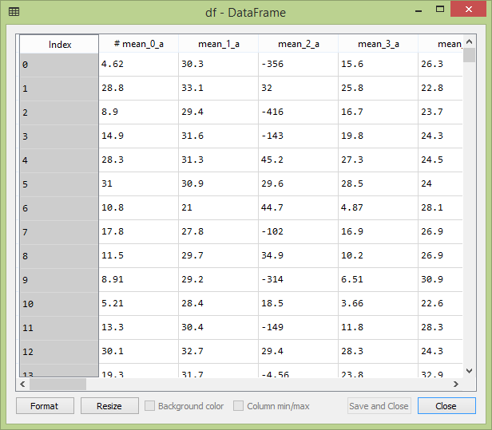

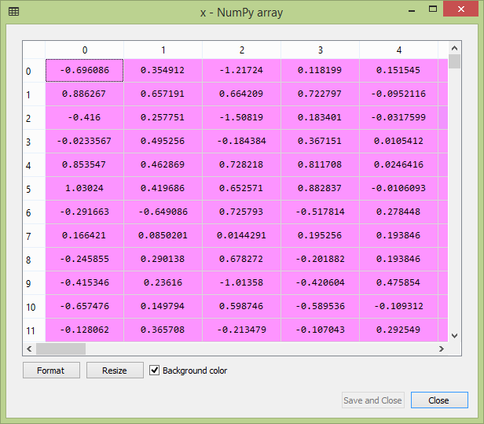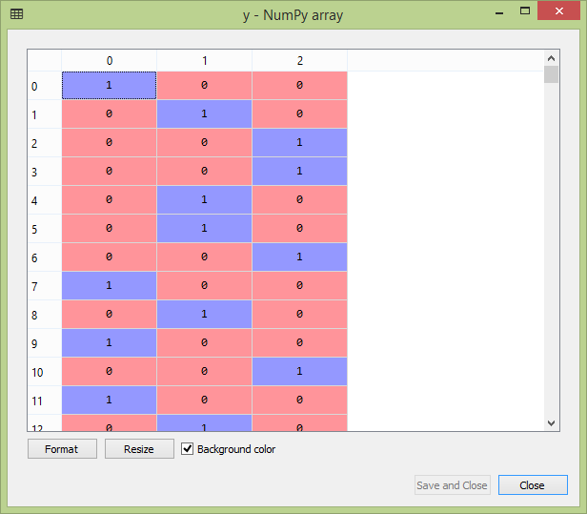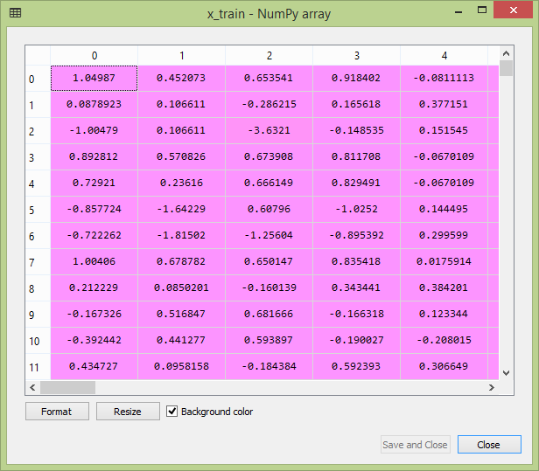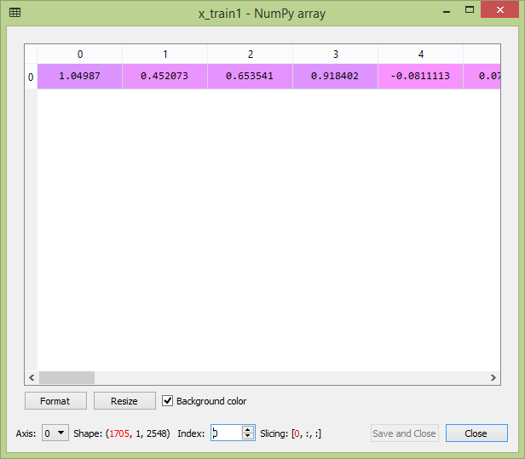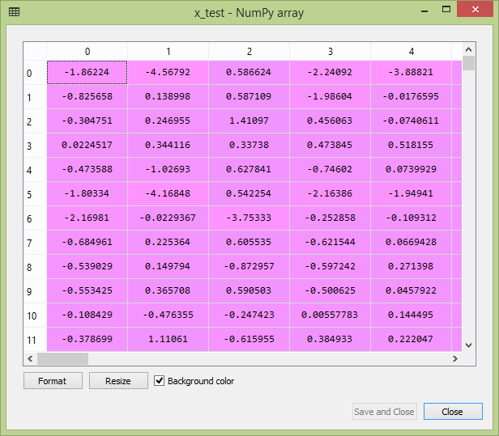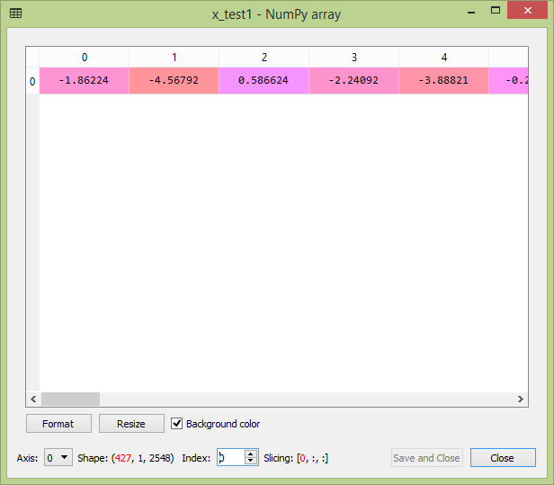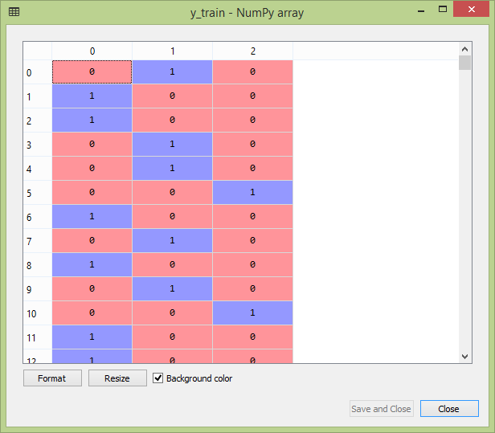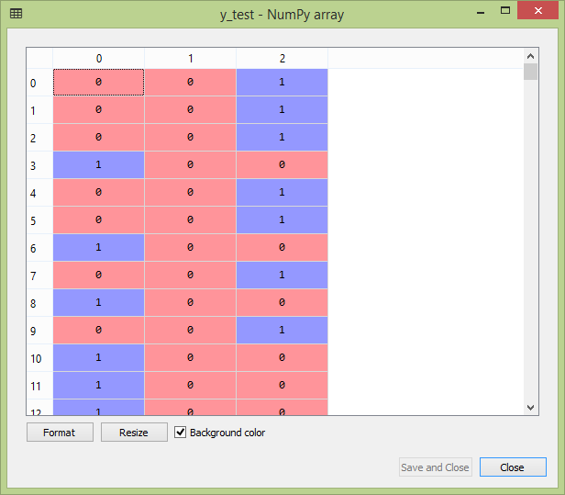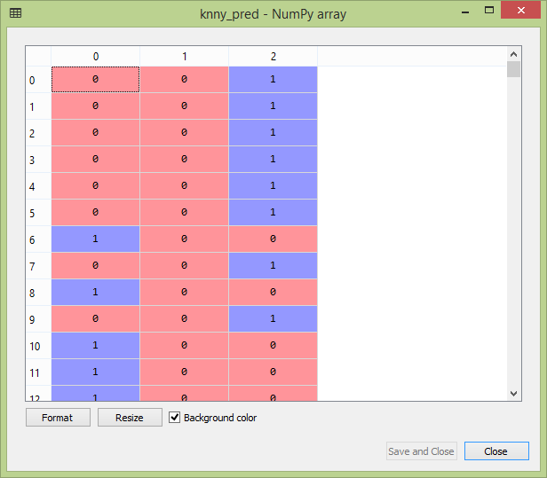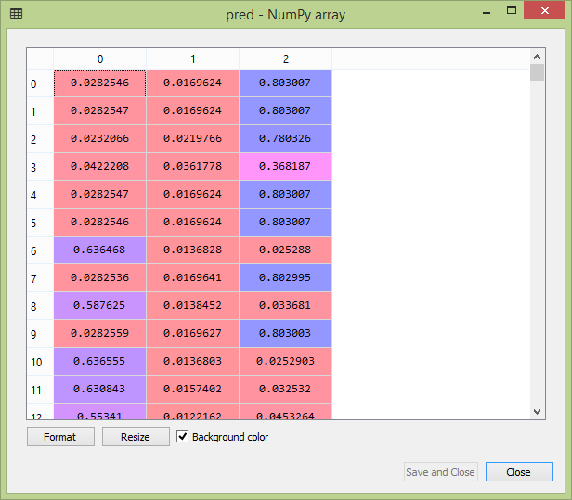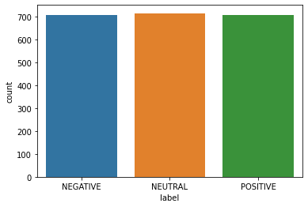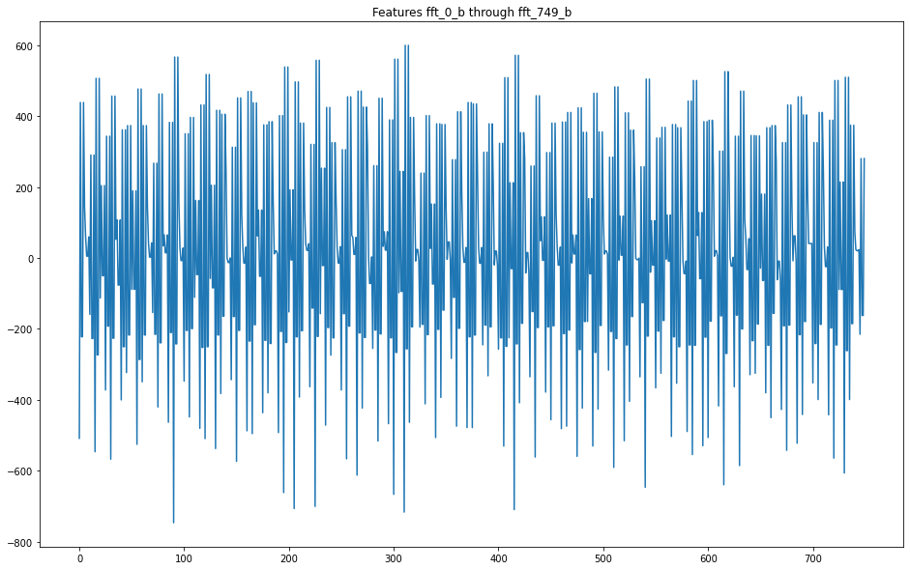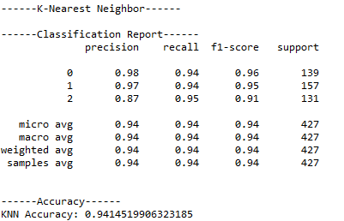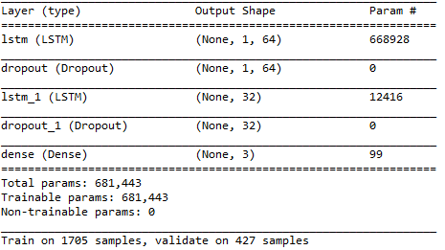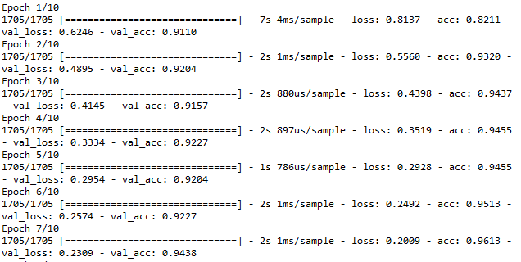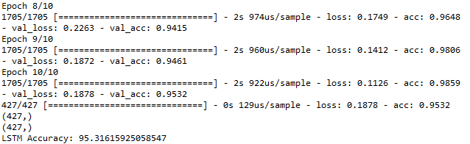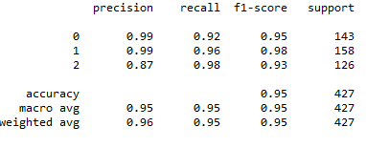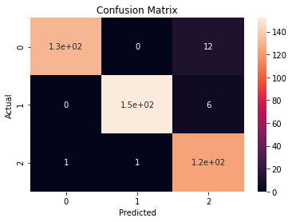

1. **REFERENCES**

[1] S. Avenevoli, J. Swendsen, J.-P. He, M. Burstein, and K. R. Merikangas, “Major depression in the national comorbidity survey–adolescent supplement: Prevalence, correlates, and treatment,” J. Amer. Acad. Child Adolescent Psychiatry, vol. 54, no. 1, pp. 37–44, Jan. 2015.

[2] M. Bachmann et al., “Methods for classifying depression in single channel EEG using linear and nonlinear signal analysis,” Comput. Methods Programs Biomed., vol. 155, pp. 11–17, Mar. 2018.

[3] I.-M. Spyrou, C. Frantzidis, C. Bratsas, I. Antoniou, and P. D. Bamidis, “Geriatric depression symptoms coexisting with cognitive decline: A comparison of classification methodologies,” Biomed. Signal Process. Control, vol. 25, pp. 118–129, Mar. 2016.

[4] J. Malik, M. Dahiya, and N. Kumari, “Brain wave frequency measurement in gamma wave range for accurate and early detection of depression,” Int. J. Adv. Res. Innov., vol. 6, no. 1, pp. 21–24, 2018.

[5] Y. Liu, H. Zhang, M. Chen, and L. Zhang, “A boosting-based spatialspectral model for stroke patients’ EEG analysis in rehabilitation training,” IEEE Trans. Neural Syst. Rehabil. Eng., vol. 24, no. 1, pp. 169–179, Jan. 2016.

[6] A. R. Ozcan and S. Erturk, “Seizure prediction in scalp EEG using 3D convolutional neural networks with an image-based approach,” IEEE Trans. Neural Syst. Rehabil. Eng., vol. 27, no. 11, pp. 2284–2293, Nov. 2019.

[7] U. R. Acharya, V. K. Sudarshan, H. Adeli, J. Santhosh, J. E. W. Koh, and A. Adeli, “Computer-aided diagnosis of depression using EEG signals,” Eur. Neurol., vol. 73, nos. 5–6, pp. 329–336, 2015.

[8] B. Hosseinifard, M. H. Moradi, and R. Rostami, “Classifying depression patients and normal subjects using machine learning techniques and nonlinear features from EEG signal,” Comput. Methods Programs Biomed., vol. 109, no. 3, pp. 339–345, Mar. 2013.

[9] X. Li, B. Hu, S. Sun, and H. Cai, “EEG-based mild depressive detection using feature selection methods and classifiers,” Comput. Methods Programs Biomed., vol. 136, pp. 151–161, Nov. 2016.

[10] T. T. Erguzel, S. Ozekes, O. Tan, and S. Gultekin, “Feature selection and classification of electroencephalographic signals: An artificial neural network and genetic algorithm based approach,” Clin. EEG Neurosci., vol. 46, no. 4, pp. 321–326, Oct. 2015.

[11] S.-C. Liao, C.-T. Wu, H.-C. Huang, W.-T. Cheng, and Y.-H. Liu, “Major depression detection from EEG signals using kernel eigen-filterbank common spatial patterns,” Sensors, vol. 17, no. 6, pp. 1385–1404, Jun. 2017.

[12] X. Li, B. Hu, J. Shen, T. Xu, and M. Retcliffe, “Mild depression detection of college students: An EEG-based solution with free viewing tasks,” J. Med. Syst., vol. 39, no. 12, p. 187, Dec. 2015.

[13] J. Yang et al. “Resting state EEG based depression recognition research employing voting strategy method,” in Proc. IEEE Int. Conf. Bioinf. Biomed., Madrid, Spain, Dec. 2018, pp. 2666–2673.

[14] C.-T. Wu, D. G. Dillon, H.-C. Hsu, S. Huang, E. Barrick, and Y.-H. Liu, “Depression detection using relative EEG power induced by emotionally positive images and a conformal kernel support vector machine,” Appl. Sci., vol. 8, no. 8, p. 1244, Jul. 2018.

[15] X. Li et al., “EEG-based mild depression recognition employing convolutional neural network,” Med. Biol. Eng. Comput., vol. 57, no. 6, pp. 1341–1352, 2019.

[16] B. Güntekin and E. Ba¸sar, “Review of evoked and event-related delta responses in the human brain,” Int. J. Psychophysiol., vol. 103, pp. 43–52, May 2016.

[17] A. Wolff et al., “Atypical temporal dynamics of resting state shapes stimulus-evoked activity in depression—An EEG study on rest–stimulus interaction,” Frontiers Psychiatry, vol. 10, pp. 719–793, Oct. 2019.

[18] Y. Li et al., “Beta oscillations in major depression–signalling a new cortical circuit for central executive function,” Sci. Rep., vol. 7, no. 1, pp. 21–36, Dec. 2017.

[19] X. Li, B. Hu, T. Xu, J. Shen, and M. Ratcliffe, “A study on EEG-based brain electrical source of mild depressed subjects,” Comput. Methods Programs Biomed., vol. 120, no. 3, pp. 135–141, Jul. 2015.

[20] M. T. Arslan, S. G. Eraldemir, and E. Yildirim, “Subject-dependent and subject-independent classification of mental arithmetic and silent reading tasks,” Int. J. Eng. Res. Develop., vol. 9, no. 3, pp. 186–195, Dec. 2017